

Object Oriented Programming Project

Course code: CS217

BS (CS)-C

Batch: Fall 2018

**Submitted by:**

Hassan Shahzad 18I-0441

**Date of Submission:**

09-12-2019

**OOP’s Bubble Pop**

**(ScreenSaver)**

**Classes Structure:**

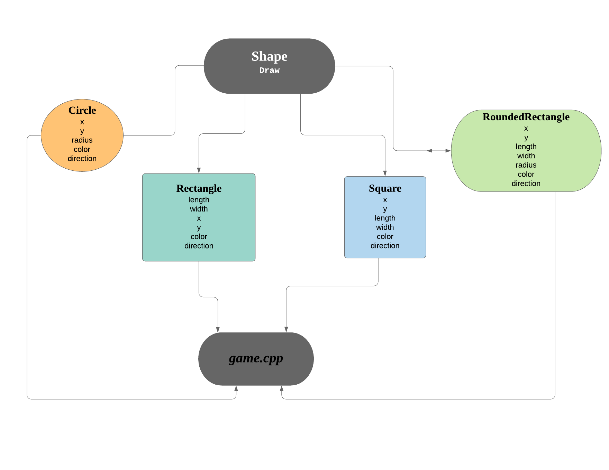

**Classes:**

* Shape
* Circle
* Rectangle
* Square
* RoundedRectangle

**Inheritance:**

The parent class i.e. **Shape** is an abstract class having a pure virtual function **Draw()**. This draw has been defined differently in each class such as in the **Rectangle** class, it has been defined by using the **DrawRectangle()** function from **util.h**. Similarly in **Circle** class, it has been defined using **DrawCircle()** from **util.h** . In **Square** class, it has been defined using **DrawRectangle()** from **util.h** by keeping the length and width same. And in **RoundedRectangle** class, it has been defined using **DrawRoundedRectangle()** function from **util.h** .

**Class Details:**

**Shape:**

* virtual void Draw()=0;

**Rectangle:**

* x
* y
* length
* width
* direction
* color

**Circle:**

* x
* y
* radius
* direction
* color

**Square:**

* x
* y
* length (same as width)
* width (same as length)
* direction
* color

**RoundedRectangle:**

* x
* y
* length
* width
* radius
* direction
* color

**(Game)**

**Classes Structure:**

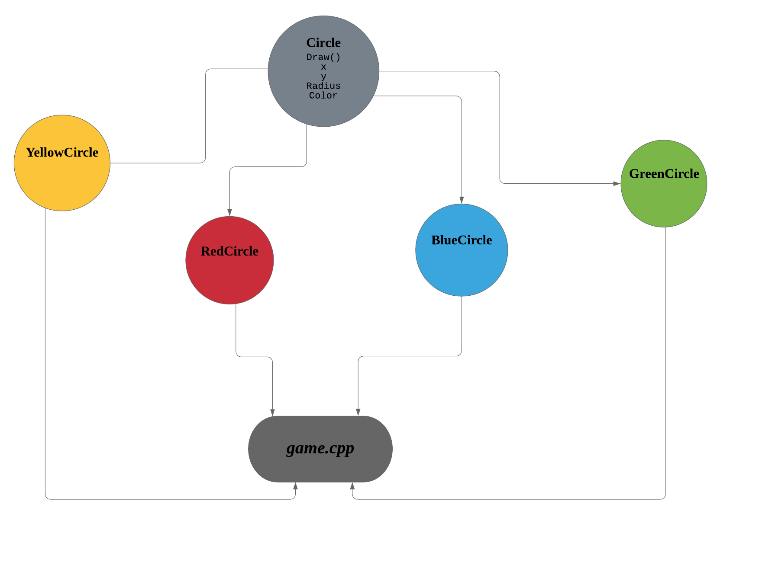

**Classes:**

* Circle
* YellowCircle
* RedCircle
* BlueCircle
* GreenCircle

**Inheritance:**

The parent class i.e. **Circle** is a pure virtual class having an abstract function naming **Draw()** which has a function in its definition which is **DrawCircle()** .This function is taken from the header file **util.h**. Now the function **Draw()** has been inherited and its definition has been altered inside the game through changing the colors in each class.

**Polymorphism:**

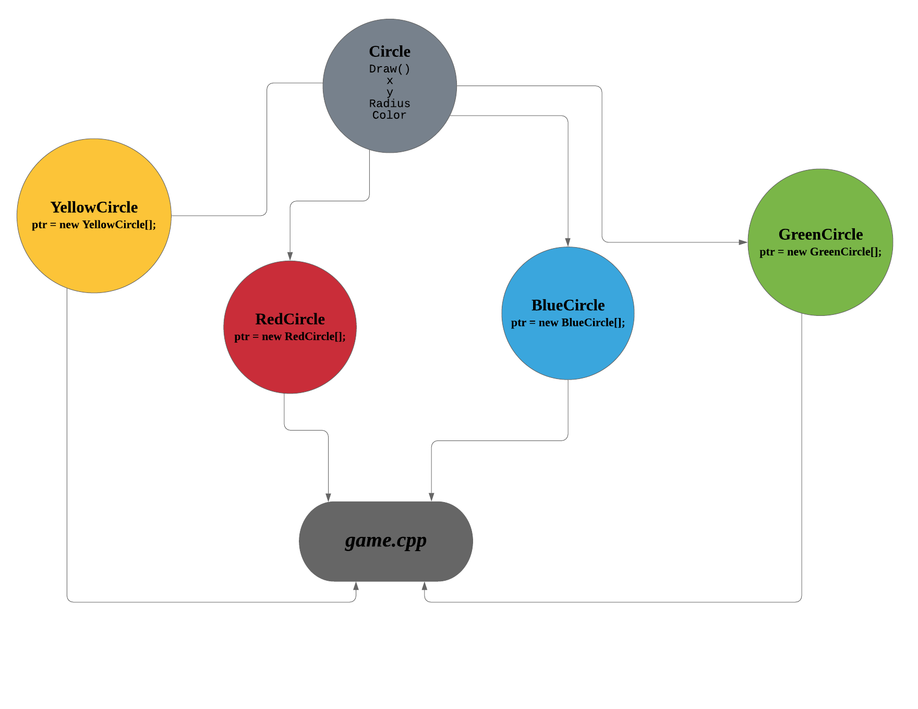

**Polymorphism** was used while creating circles and dragging it to collide with others. A **pointer** of the parent class was declared i.e. **Circle *ptr** . Using this pointer we **dynamically** allocated memory **to array of objects** of all of the remaining classes. Furthermore this polymorphism was also used in following functions:

* DrawCircle()
* CollisionCheck()
* MouseClicked()
* MouseMovedAndDragged()
* Display()

**Game Interface:**

**Menu:**

Upon the start of the game, a menu is displayed consisting of 5 options:

* Start Game
* Rules
* Instructions
* High Scores
* Exit Game

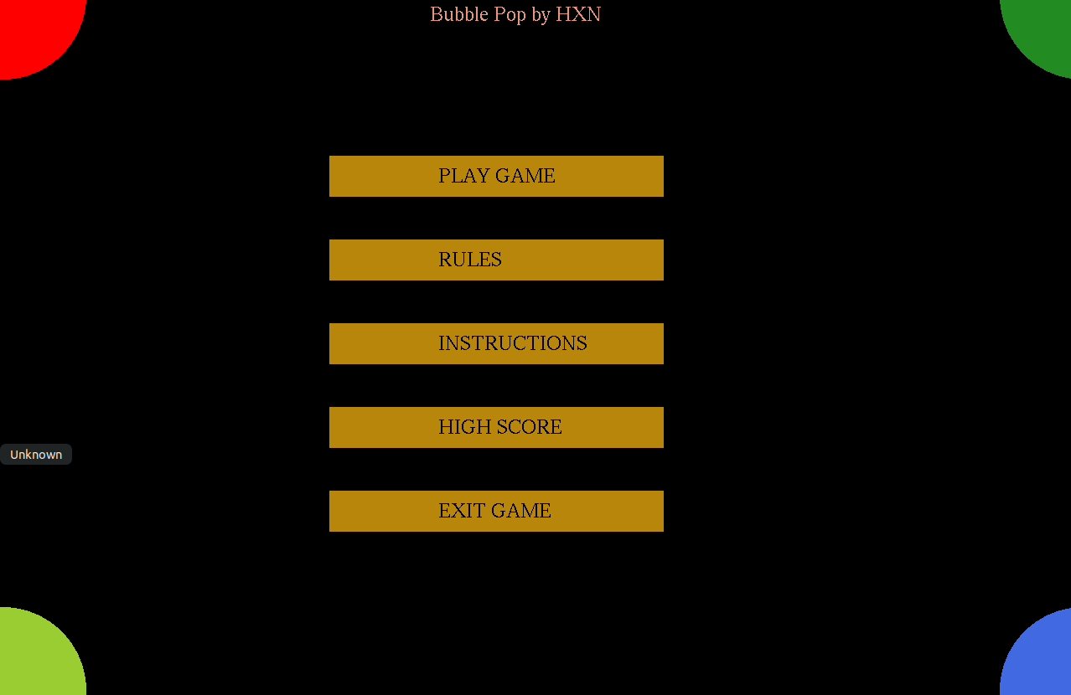

**1: Start Game:**

**1.1: Color Choice:**

Upon the start of game user is given 4 circles of different colors to select from.

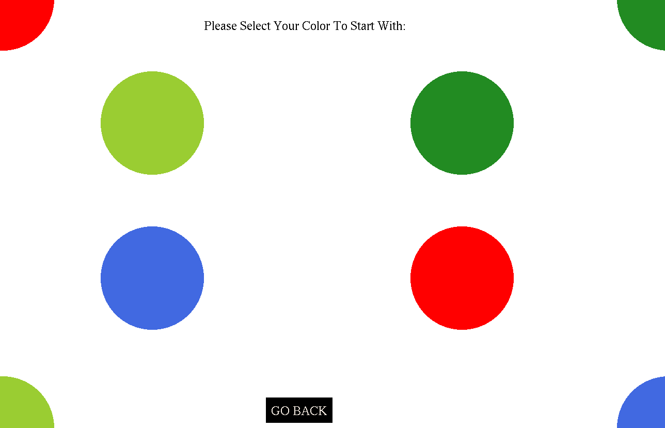

**2: Rules:**

When user presses the Rules option, he’ll be directed to a screen with 4 rules.

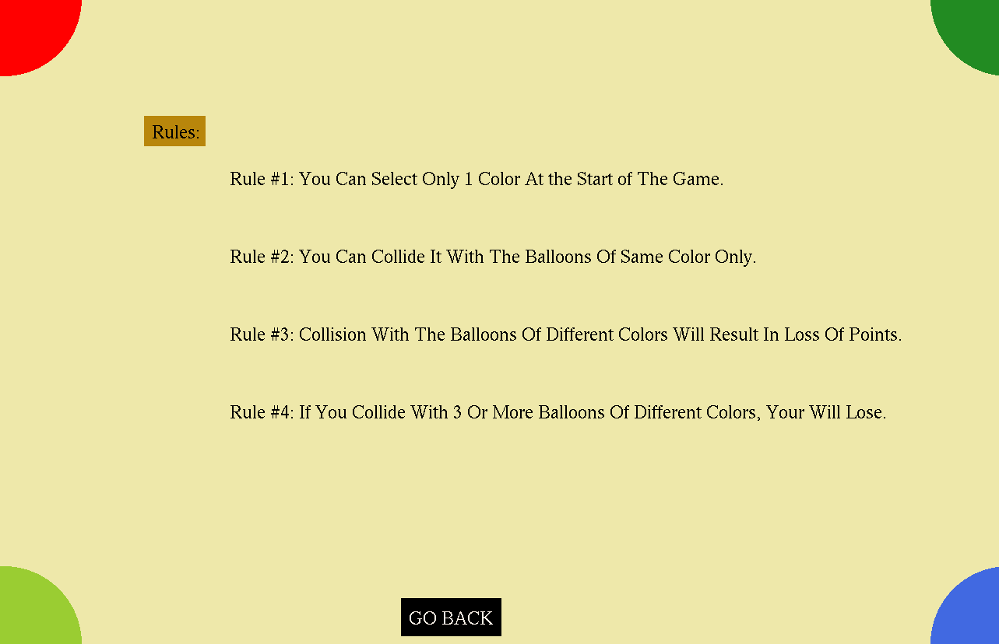

**3: Instructions:**

When user presses the Instructions option, he’ll be directed to a screen with instructions for game.

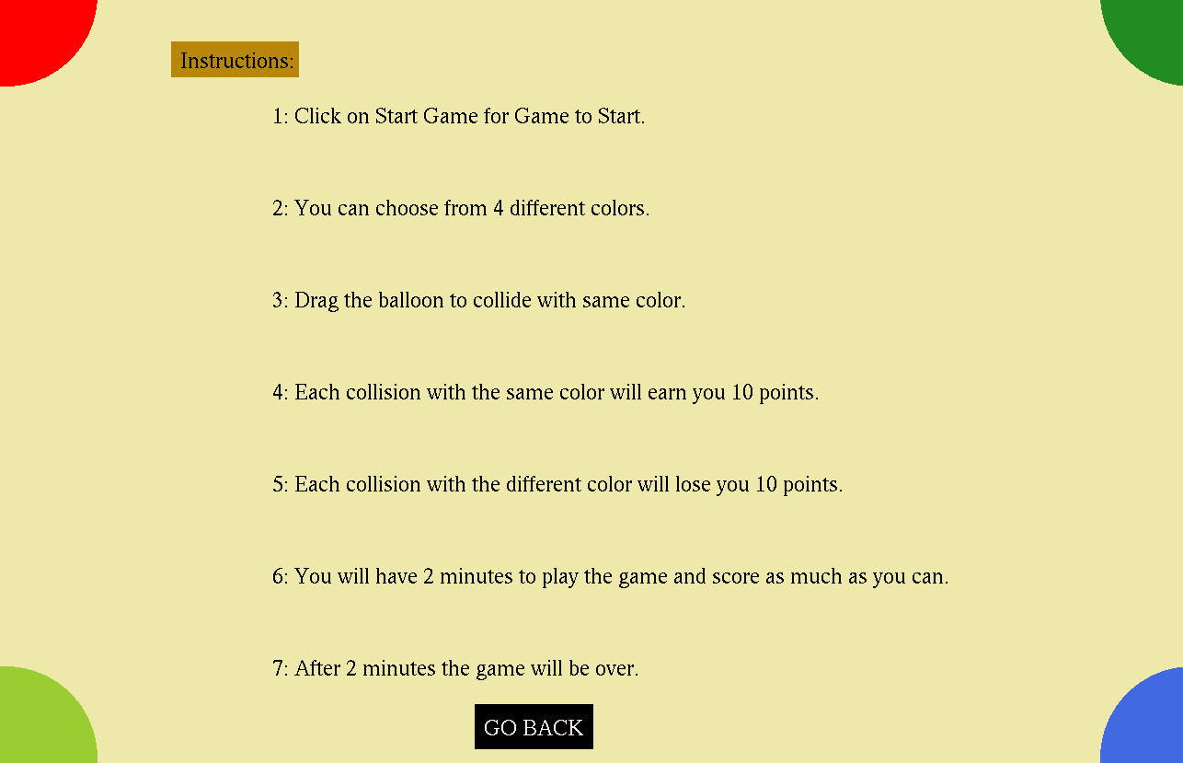

**4: High Score:**

When user presses the High Score option, High Score will be displayed in a new screen.

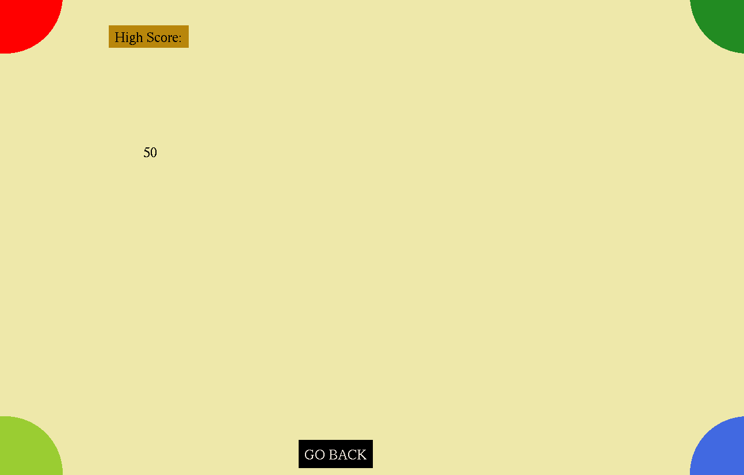

**5: Exit Game:**

When user presses this option, game will be exited.

**Bonus Works:**

* Menu
* Score
* Timer (Game will be played for 2 minutes only)
* File Handling
* Polymorphism
* Merging of Shape
* Color Changing after collision
* Go Back Button